Client Categories for Identifying Parolees Tip Sheet

To locate Client Categories, click the Systems Button, follow the path: Client Data, Client assignments, Client categories Maintenance:
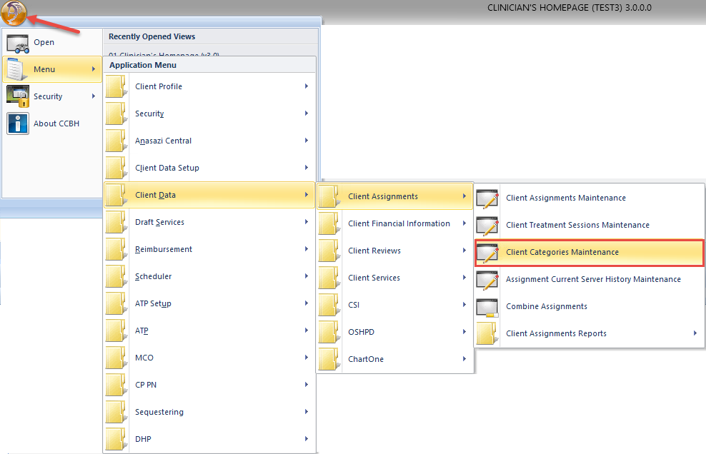

In the Client Categories Maintenance, make sure your client name is entered. Then Click in the green Category field to reveal the blue field with magnifying glass:
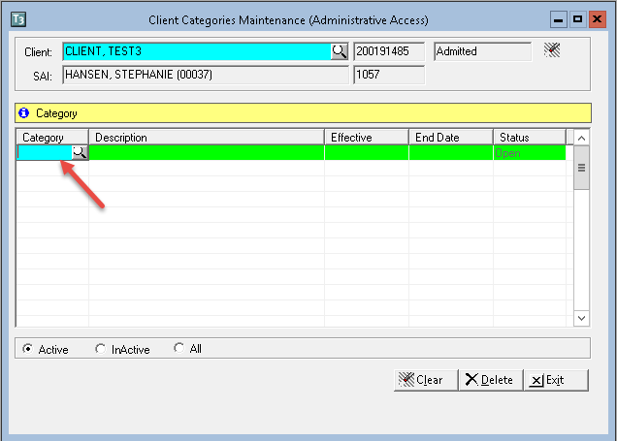

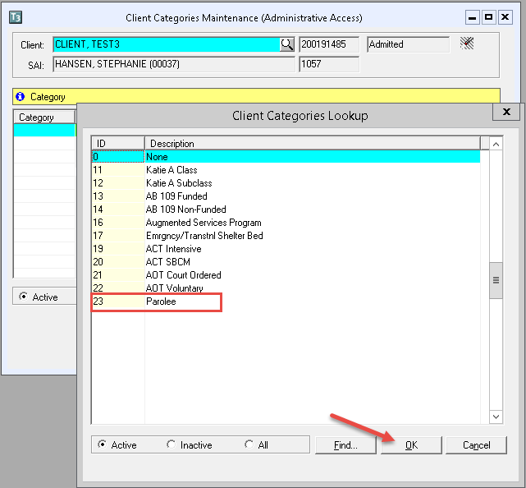
Click on the magnifying glass and select Parolee from the drop-down menu. Click OK:
Enter in the Effective Date field the date of client’s assignment. Then Tab-through until the next line highlights. This saves the entry. Then click Exit:
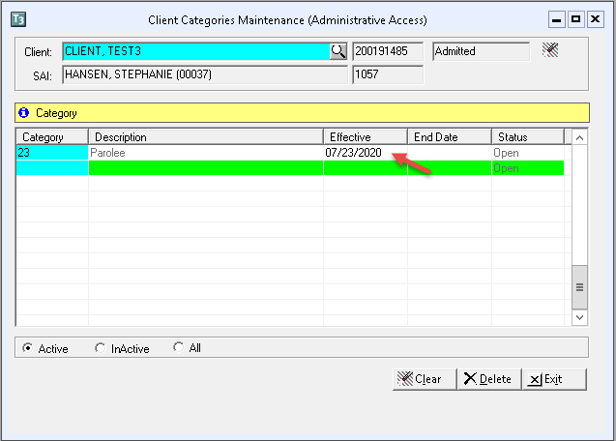

To remove the Client Category, click on the category to be deleted enter in End Date the assignment closing date, and click Delete. When the Confirm window displays, click Yes. Then click Exit:
