To: Mental Health System of Care Providers
From: Steve Jones, LCSW, QM Program Manager
Date: September 22, 2014

Re: Interactive Service Codes and a New Add-On Service Code 785

Currently, BHS System of Care has four (4) Interactive Service codes. Interactive codes are used when a service activity is performed by using play equipment, TTY, or a language interpreter. Recently, a new process for claiming for interactive services has been developed for immediate implementation. Interactive service codes must now be accompanied by an “Add-On” code, which is Service Code 785. This Add-On code is only to be used when an Interactive service code is entered and must be entered along with the primary service code at the time of service entry. Service code 785 attaches to the primary service code when the claim is processed.

These primary interactive service codes are listed below:
- 9 Assessment- Psychosocial Interactive
- 38 Psychotherapy Interactive- Individual
- 39 Psychotherapy Interactive- Group
- 115 Medication Evaluation- INT

Effective today, all Interactive Service Codes must be accompanied by Add –On Service Code 785

Below is in an example of interactive code 9 (assessment psychosocial interactive) with the add-code 785 entered as a separate service entry.

- Complete and final approve the progress note and service entry for the interactive code.

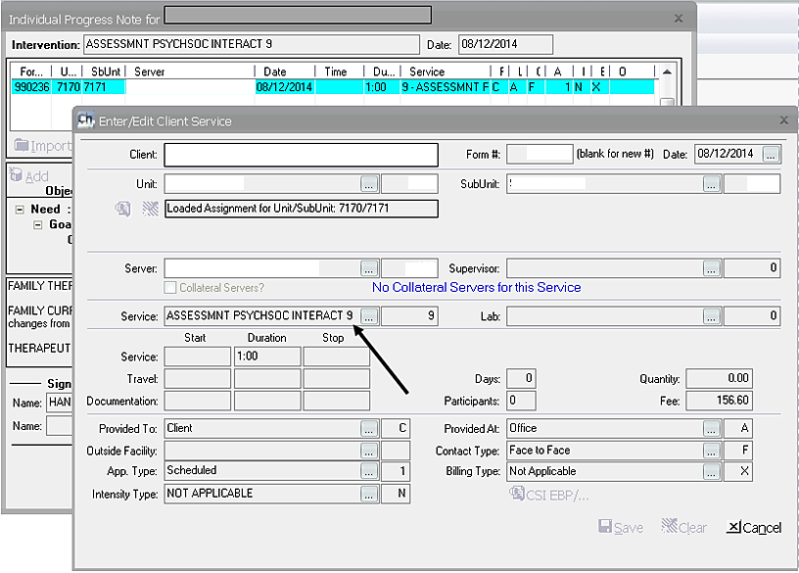

- Open up a second individual progress note for entry of Add-On SC 785. In the service entry screen, enter add-on code 785.

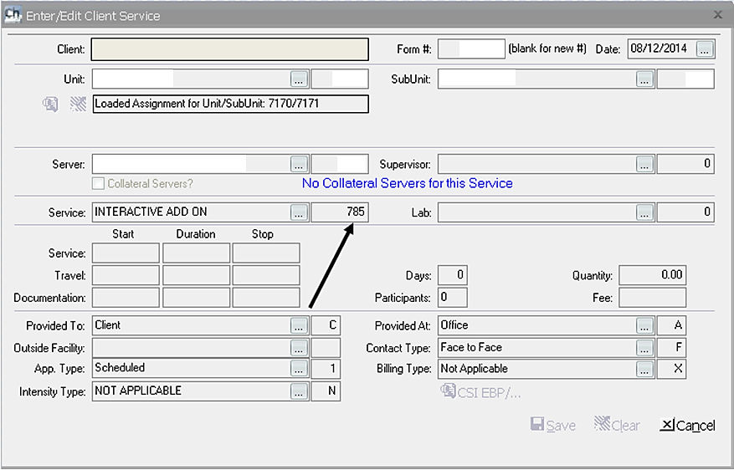

Service, travel and documentation time are not documented as those fields are disabled for SC 785. Service indicators (i.e. Provided At:, etc.) will default, however, you must enter the service indicators to match those entered for the interactive code.

- The narrative of the Service Code Interactive Add On 785 progress note should document which interactive code the Add-On is attached to, for example, “Add-On for SC 9”.

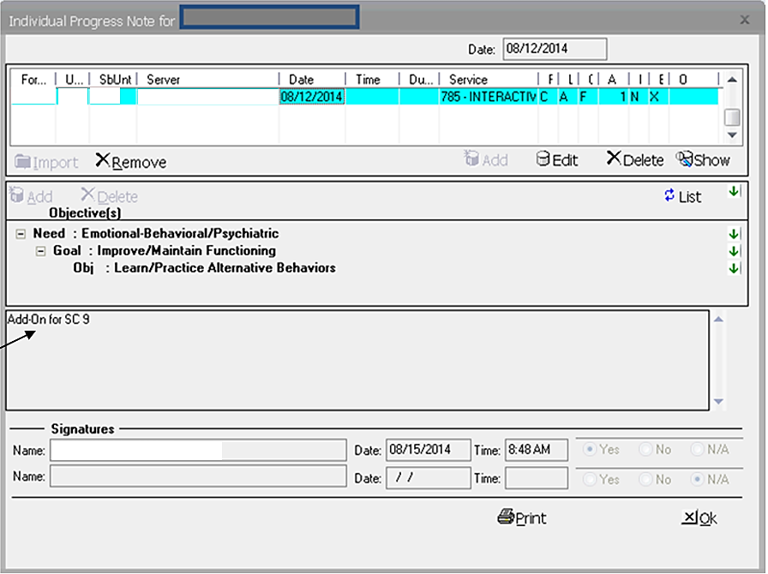

This change is effective immediately. Programs should instruct their staffs on how to enter interactive services with the new procedure.

Please direct questions to the QI Matters mailbox: QIMatters.HHSA@sdcounty.ca.gov

